Day-1: Terraform(resource block, data block): Created VPC, IGW, Route Table(RT) attached to IGW, Public Subnet, Route Table Association to public subnet, Security Group(“Allow all inbound traffic and all outbound traffic”), Data-Source:
1)resource block:
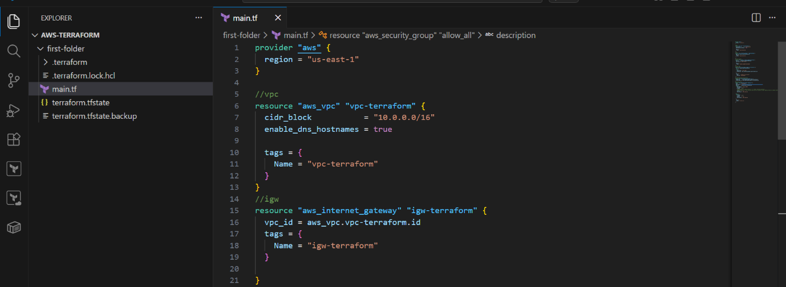
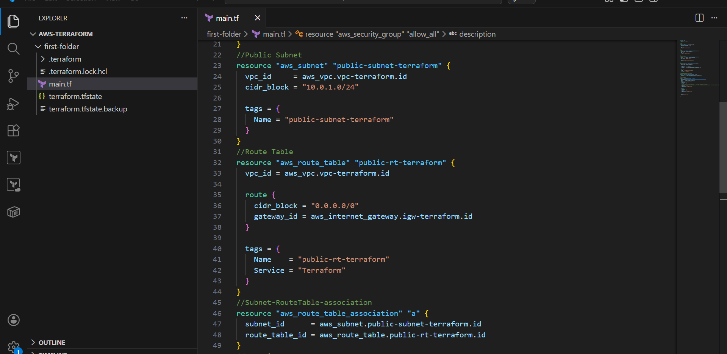
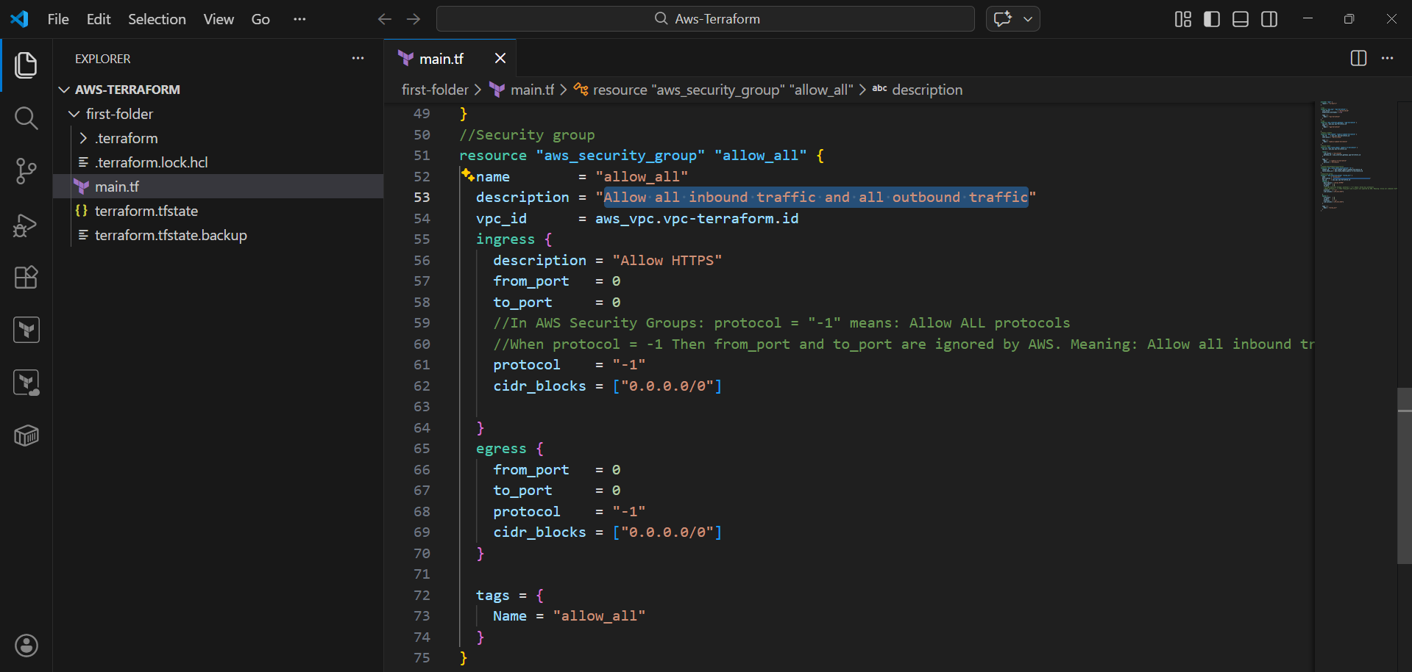
----------
Output:
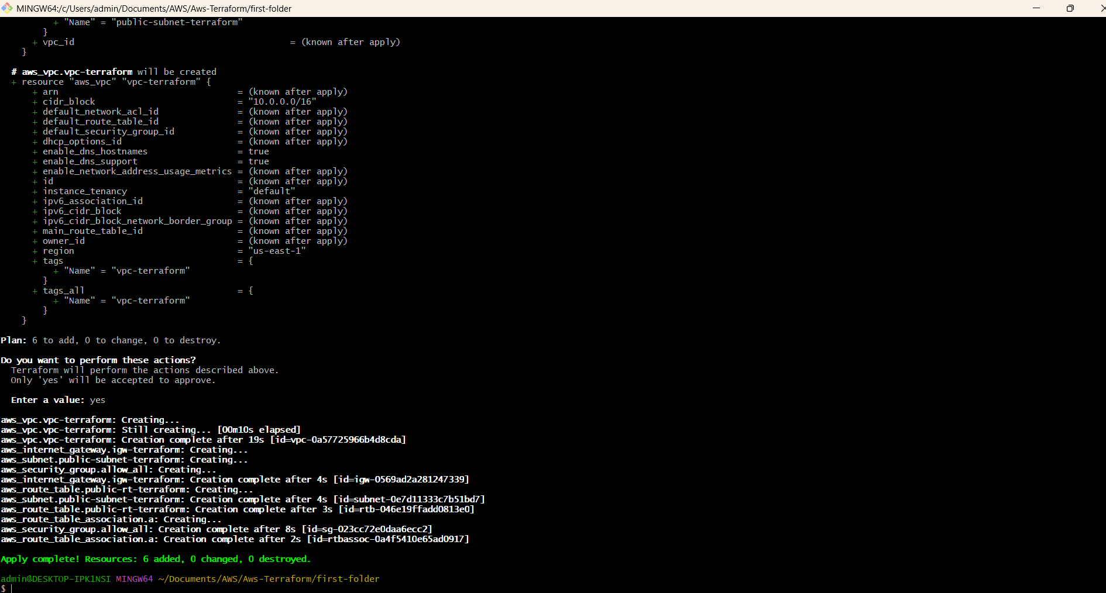

2)data block:
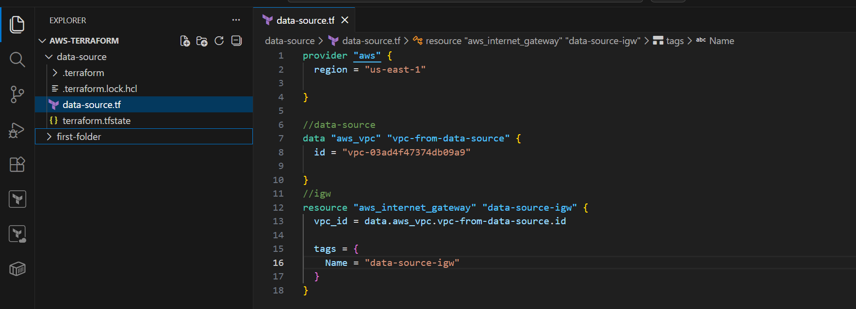
OutPut:
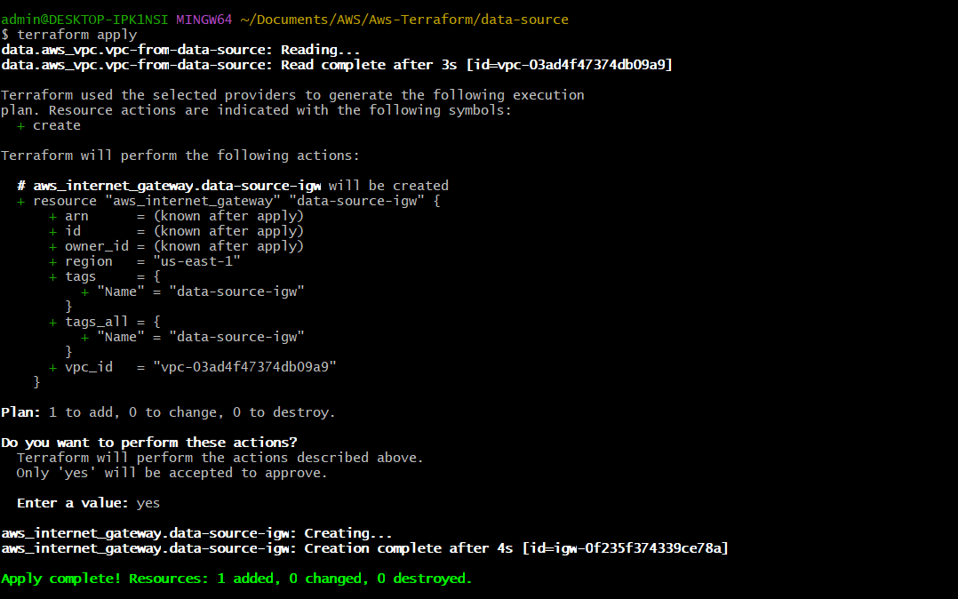
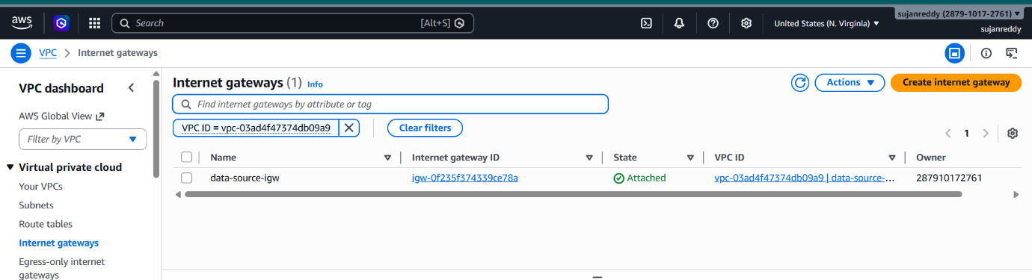
--------
Task: 1st terraform project: created vpc, public subnets, route table, security group and in 2nd terraform project: created ec2 instance and gave subnet_id and security group id with the help of data sources:
